

**A 12**

**Sreenidhi Institute of Science & Technology**

(An Autonomous Institution)

**CODE NO: 121ME02**

**B. TECH. I – YEAR II – SEMESTER EXAMINATIONS, JULY, 2014 (REGULAR)**

**ENGINEERING DRAWING – II (Common to EEE,ME,ECM & IT)**

**Time: 3 Hours Max. Marks: 70**

**Note: No additional answer sheets will be provided.**

**Part-A**

**Max.Marks:20**

**Answer all QUESTIONS.**

1. Define Representative fraction. Write down the formula to calculate length of scale.
2. Name any two methods to get the development of solids.
3. Find the isometric length of 80mm using isometric scale.
4. Define orthographic projection.
5. Define angle of vision.
6. Write any four editing commands used in CAD.
7. Write any three differences between first angle projection and third angle projection.
8. How do you classify scales in engineering?
9. Name any two coordinate methods used in CAD to locate a point.
10. Draw the isometric view of regular pentagon of side 25mm.

**Part – B**

**Max. Marks: 50**

**ANSWER ANY FIVE QUESTIONS. EACH QUESTION CARRIES 10 MARKS.**

1. The actual length of 500m is represented by a line of 15 cm on a drawing. Construct a vernier scale to read up to 600m. show a length of 529m and 206m on it.
2. Construct a Diagonal Scale of 1:40 to read metres, decimeters and centimeters and long enough to measure up to 6m. Mark a distance of 4.7m on it.
3. A cylinder of base 50mm diameter and 60mm long is resting on the ground on its base with its axis perpendicular to HP. It is cut by a section plane inclined at 400to H.P.passing through a point at 40mm below the top end of the axis. Draw the development of lateral surface of the remaining part of the cylinder.
4. A straight line of 50mm long is parallel to and 20mm above the ground plane, and inclined at 300 to the picture plane. One end of the line is 20mm behind the picture plane. The station point is 40mm above the ground plane, 50mm in front of the picture plane and lies in a central plane which passes through the midpoint of the line. Draw its perspective view.

Page 1 of 2

1. Draw front view , top view and side view of the given figure.

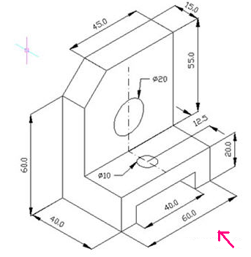

1. a) What are the main functions of CAD system.

b) What are the applications of the CAD system.

1. Draw the isometric projection of a sphere of radius 20mm when it is centrally located on a square prism of side of the base 50mm and height 30mm long.
2. Draw the isometric view from the given views.

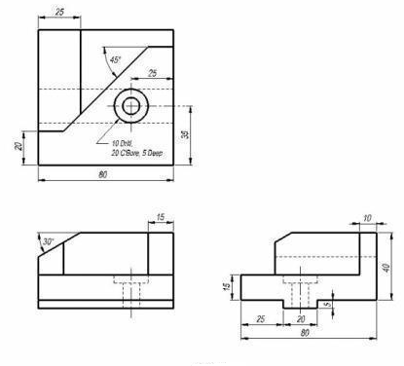

**--00 -- 00—**

Page 2 of 2